|  |
| --- |
|  |
| Sfwr Eng 4HC3 |
| Assignment 2: Design Document |
|  |
| **Zichen Jiang jiangz26 001320889**  **Kelvin Lin linkk4 001401464** |
|  |

|  |
| --- |
|  |

Table of Contents

Introduction 2

Functionality 2

Context 2

The Application Layout 2

Selecting a Language 3

Providing a Bank Account Number 4

Entering a Passcode 6

Success 6

Failure 7

The Main Menu 8

Withdraw Money 9

Success 10

Failure 10

Deposit Money 11

Transfer Money 14

Success 15

Failure 17

Check Balance 17

Change Passcode 19

Sign Out 21

# Introduction

This document details a touchscreen ATM interface created by Zichen Jiang and Kelvin Lin for Sfwr Eng 4HC3.

## Functionality

The ATM can validate users through three different input methods: inserting their bank card, swiping their bank card, or entering an account number. Afterwards, the ATM will ask the users to enter a passcode associated with their account. As a security feature, users will be given three attempts to enter this passcode. If they enter it incorrectly three times the account will be locked out of the system, and a message will be displayed to the users telling them to go to the bank to unlock their account.

Once the users validate their account, they will be directed to a menu where they can select their desired tasks: withdraw, deposit, transfer, check balance, change passcode, and sign out. The withdraw feature lets users withdraw money from the ATM, provided they already have money in their account. Users can also add money to their account using the deposit feature. Users can transfer money to other users, if they have their bank number. Users can check their current balance, as well as their transaction history, using the check balance feature. Users can change the passcode associated with their account using the change passcode feature. Finally, users can sign out of the system using the sign out feature.

## Context

While the functionality of the system is universally accepted, the design of systems is constrained by cultural and societal beliefs and values. Different societies develop different conceptual models and have different expectations of how a system should work. In order to design a good interface – one that can be used by 95% of the population – a target population of users must first be described.

The target audience for the ATM machine will be the working population. This includes everyone 15 years of age and up. About 85.6% of Canadians have working knowledge of English, while 30.1% have working knowledge of French [1]. Aside from Canada’s official languages, the next most commonly used languages in Canada are Chinese, Punjabi, Spanish, and Tagalog. It will be assumed that most Canadians have prior experience with touch screens and ATMs, even if they are not contained within one system.

# The Application Layout

The application is divided into two components: the ATM system, and simulated physical controls. The main ATM system is located at the top of the screen, and it is enclosed in a black border. The black border is not intended to be part of the system: it is there to separate the ATM system from the simulated physical controls.

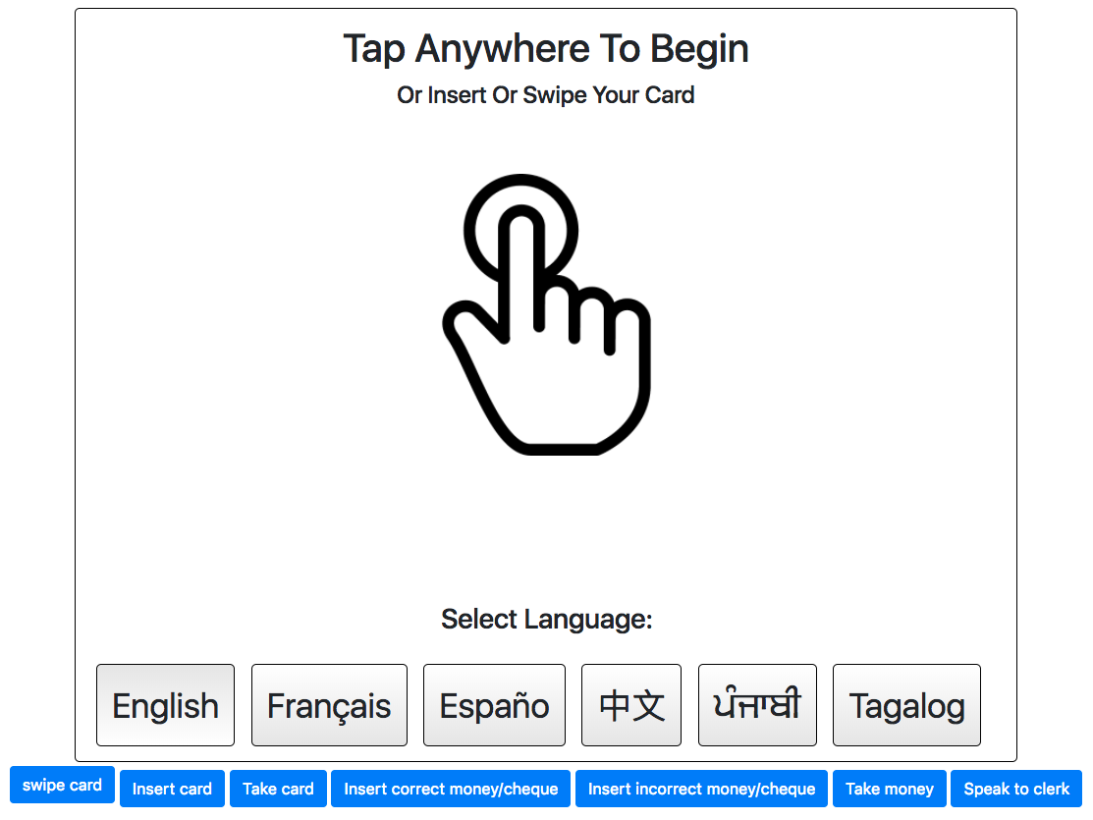

**Figure 1: The Application Layout**

There are seven buttons below the application. The first six buttons act as physical controls to the system. They simulate actions that the users can perform on the ATM without accessing the touchscreen interface. Such actions are swiping their bank card, inserting their bank card, removing their bank card, taking money from the machine, inserting money into the machine, and inserting the incorrect amount of money into the machine. The last action they can perform is speaking to the bank clerk. It is not an action the users can perform with the ATM. The action unlocks a locked bank account.

The console is also used to denote simulated physical interactions that the users can have with the ATM. Such actions include the card reader being blocked, no money is dispensed from the machine, or the deposit box is closed.

# Selecting a Language

Since Canada is a multicultural society, multiple languages will be supported. The ATM supports English, French, Spanish, Chinese, Punjabi, and Tagalog. English and French are supported because they are the official languages in Canada, and most Canadians have a working knowledge of either English or French. The other 4 supported languages are the four most commonly used unofficial languages in Canada. Supporting these languages ensures that 95% of the Canadian population can use the ATM.

The actual localization functionality was not implemented. This is because the localization feature does not add to the overall design of the application. The application would still look the same in different languages. One interesting consideration for the future might be to mirror the ATM application for languages that read right to left, since people who read in those languages are more likely to scan the right-hand side of the screen first. Therefore, for languages that read right to left, important information should be placed on the right instead of the left.

Users can select a language by typing one of the six buttons on the start screen. The button with inversed color indicates that it is pressed down, and the language shown on it is the displaying language.

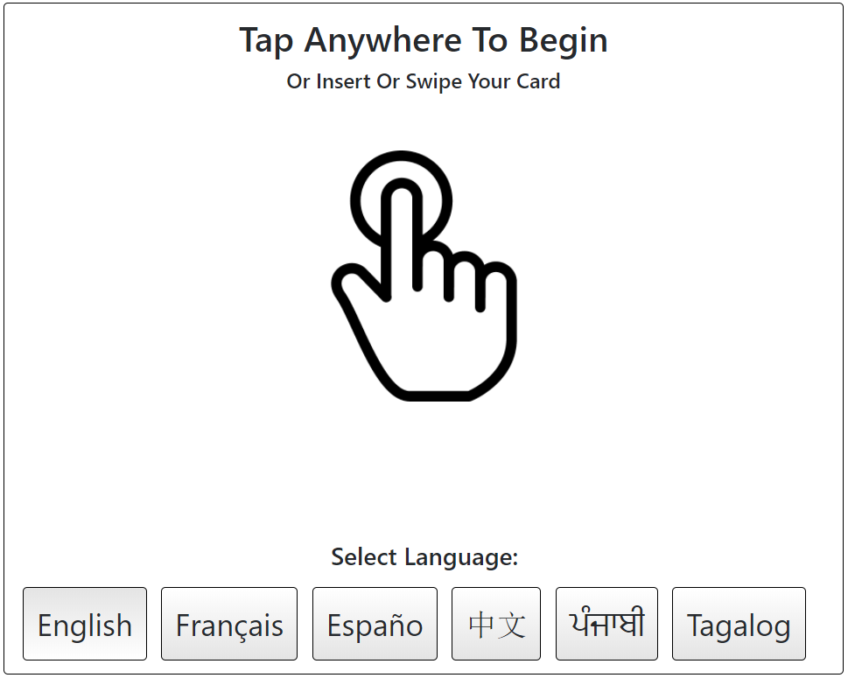

**Figure 2: Language Selection Menu**

# Providing a Bank Account Number

The first operation users make when using the ATM is providing their bank account. They can do this in three different ways: inserting their card, swiping their card, or entering their bank account number. Since inserting or swiping their card is a physical interaction, the system allows the users to preform those at any time before the users are logged in.

To enter their account number, users will need to tap on the initial screen to access the input selection menu. Afterwards, users will need to tap on the account number button to reach the interface for entering their account number. Users can use either the number pad on the touch screen or the physical number pad to enter their passcode. In the application, this is simulated as users can either press on the on-screen buttons to enter their passcode, or enter their passcode on the keyboard. It will be assumed that the physical number pad has the same keys as the onscreen number pad. Two options are given because some users may be uncomfortable typing their bank account number using a touch screen fearing that the fingerprints they leave behind may allow the next person to access their bank account. A text label below the text field will inform users they can use the physical keys.

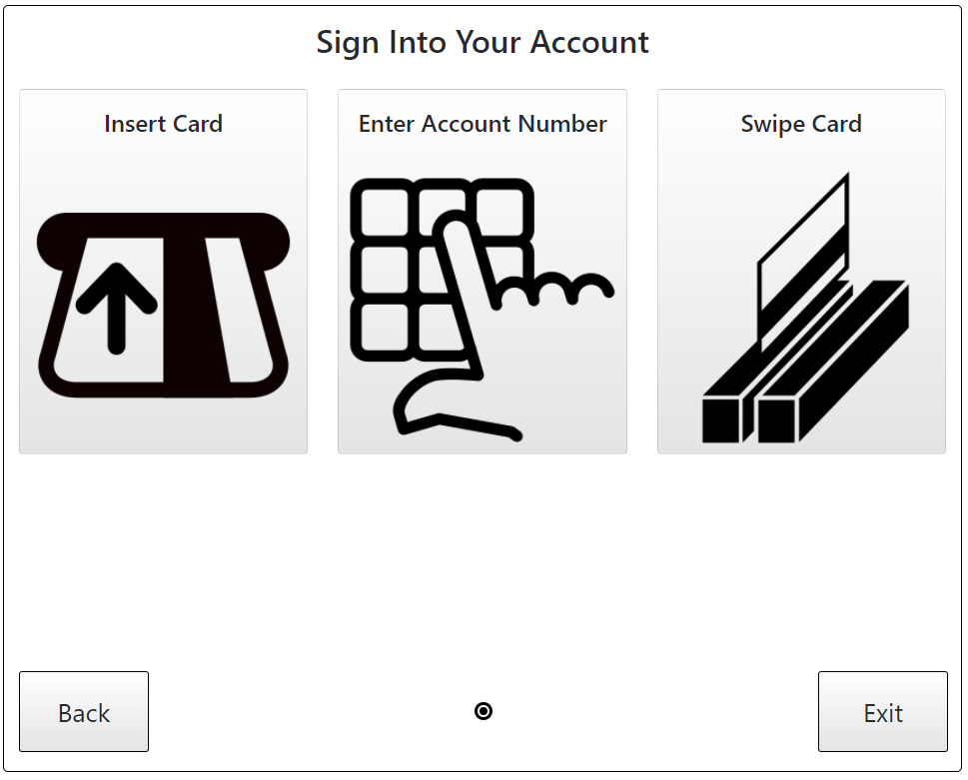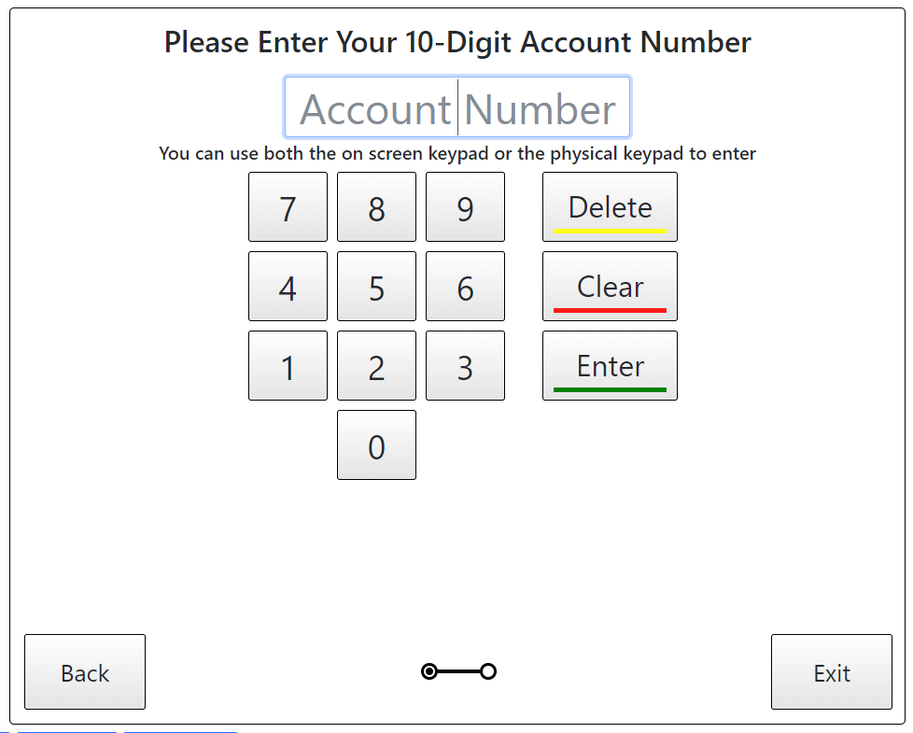

**Figure 3: Input Selection Screen Figure 4: Account Number Entry Screen**

The account number entry method is less assessable to the usesr because it is expected that option will be the least frequently used. Bank account numbers are commonly 16 digits long; however, a person’s short term memory can only hold about 7 items. Hence, it is expected that most people will not remember their bank account number, so instead of typing their bank account number from the card, they will rather insert or swipe.

In this application, bank account numbers are 10 digits long because the purpose of this application is to model strong applications of design principles rather than to create a hyper-realistic functioning system. To prevent slips such as tapping the same number twice or entering more digits than necessary, the text field is constrained to 10 digits. Users are also able to see the numbers they type in, as a bank account number is not private and is guarded by a personalized passcode.

If the account number is not valid, then the users are shown a red ‘X’ and text saying that the account number is not valid. Red is used to emphasize the significance of the event.

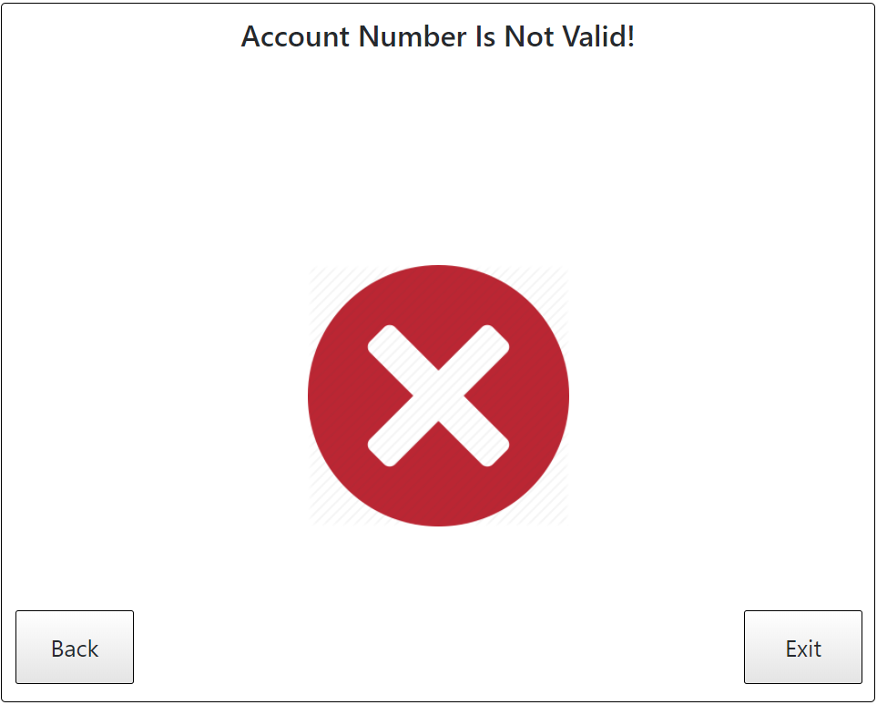

**Figure 5: Account Number is Not Valid Screen**

# Entering a Passcode

As a security feature, once the users input their bank account number, the users are also required to provide a passcode. This is intended to prevent unauthorized access to a person’s bank account. Like the bank account number, users may use either the onscreen number pad, or they may use the physical number pad attached to the ATM machine. However, unlike their bank account number, their passcode will be blocked, so users will see black circles instead of the actual numbers they typed. This is intended to give users feedback so that they know that their input was registered, while protecting their privacy against people watching behind them.

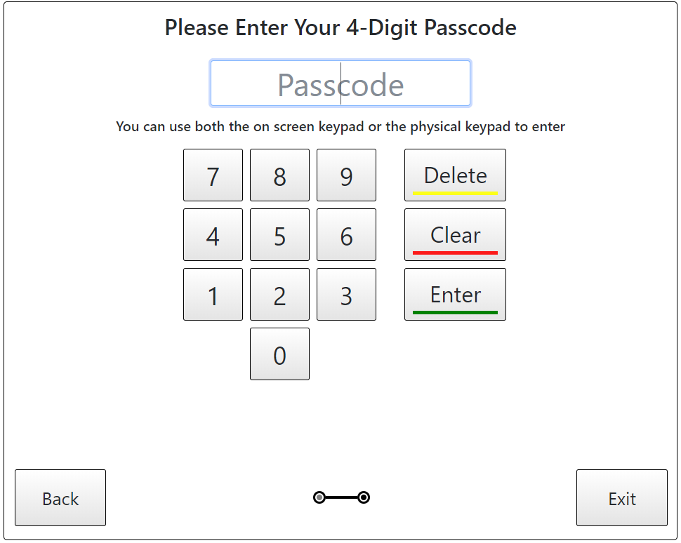

**Figure 6: Passcode Entry Screen**

Each passcode is 4 characters long, as most people can remember 4 digits in their short-term memory. Users are constrained to only entering 4 characters as any additional characters entered after the fourth character will not be registered.

## Success

If the users successfully enter their passcode, one of two actions will occur. If the users swiped their card or entered a bank account number, then they will be directed to the main menu. Otherwise, if the users inserted their card, then they will be prompted to remove their card before they are directed to the main menu. The users are asked to remove their card first so they will not forget about their card after their transactions.

Once the users remove their card, then a mechanical guard on the ATM machine prevents the users from inserting their card again until the users are signed out. Likewise, swiping a card while the users are signed in will not have any effect on the system. In this application, this is represented by messages outputted to the console.

## Failure

Users are given three attempts to enter the passcode correctly. This was done to account for slips and mistakes that users might make while entering their passcode.

If the users incorrectly enter a passcode once or twice, then they will be directed to a page with a large ‘X’ icon. The ‘X’ icon signifies to the Canadian audience that they have made a mistake. The icon uses the conceptual model of a barrier lets the users know that the previous input they provided cannot overcome the barrier. The icon is red, in contrast to the rest of the monotone interface, to emphasize the significance of the event to the users. It is assumed that most Canadian users will know that an ‘X’ is a negative signal because ‘X’s are commonly used to denote mistakes, errors, or prohibitions in signs and schools in Canada. Moreover, textual labels signal to the users the number of attempts they have remaining before the users get locked out of the system.

The buttons in the bottom signifies that the users can either go back and attempt to enter the correct passcode or exit the system. If the users inserted their bank card, the system will prompt the users to take out their card. Otherwise, the system will go back to the initial screen (Figure 2) and delete any information the users entered.

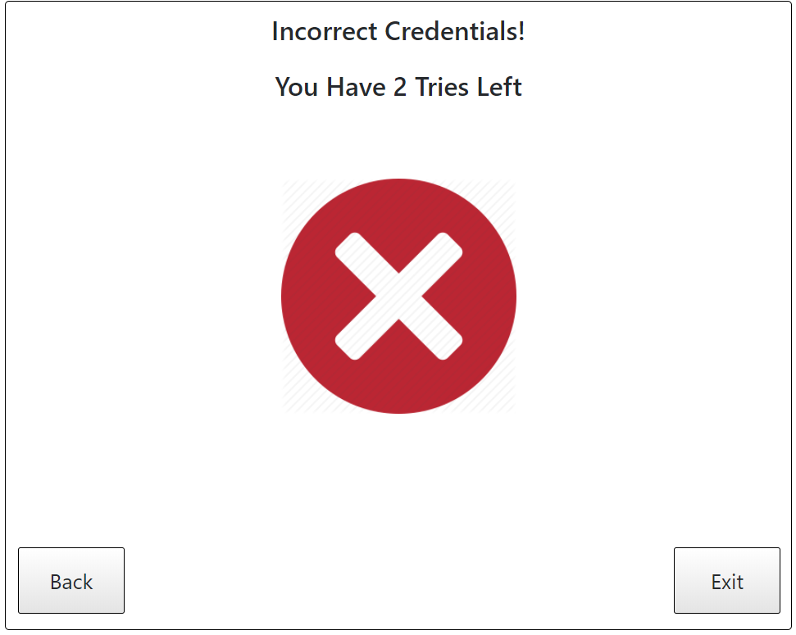

**Figure 7: Passcode Incorrect Screen**

If the users incorrectly enter their passcode 3 times, then they will be locked out of the system. A label as well as an icon of a lock signals to the users that they have been locked out of their account. The conceptual model of a lock is used to let users know that they will need to obtain a key or special permission to access their account again. The lock is black instead of red because the event is no longer in the control of the users, and hence, the users do not need to be warned of the catastrophic consequences. Text at the top of the screen will let users know that they need to talk to a clerk at the bank to get their account unlocked. The buttons in the bottom provides the users with only one action, that is to exit the system. If users inserted their bank card, the system will prompt the users to remove their card when they click on the exit button.

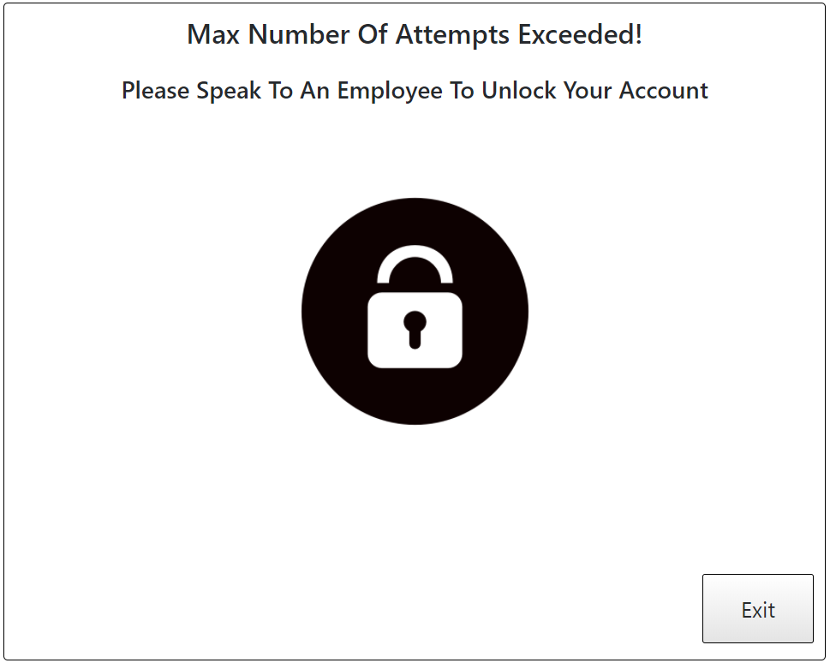

**Figure 8: Locked Out Screen**

Speaking to a clerk is simulated by an action button in the software; however, when the button is pressed, and the users are locked out, the interface will revert to the initial interface. This is to simulate the fact that the ATM interface will reset in the time it takes for the users to go to the bank and to come back.

# The Main Menu

Once the users successfully log into their bank account, they will access the main menu. To maximize discoverability, all the possible transactions are displayed in the main menu. The users can access any transaction by tapping on the corresponding button.

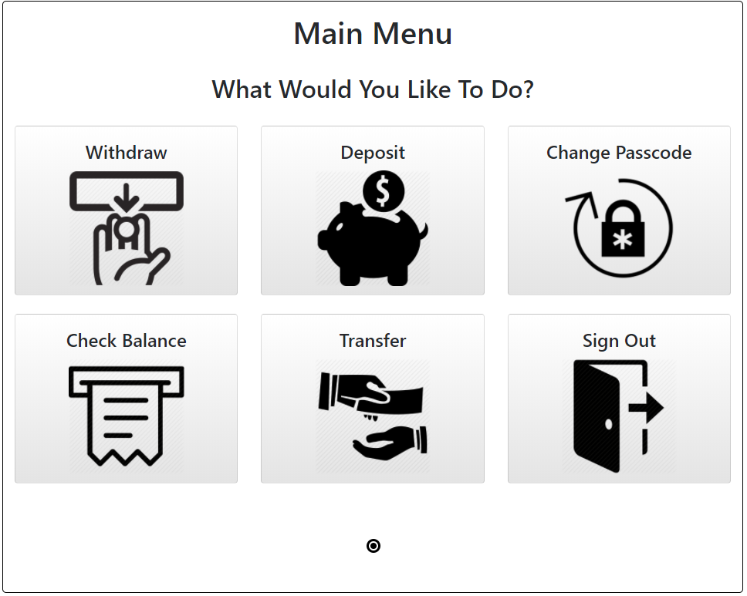

**Figure 9: Main Menu**

Showing all available actions to the users may lead to information overload if there are too many on screen elements: users may be overwhelmed by the number of elements on the screen and decide to ignore important information. To avoid information overload, labels and pictures were used in tandem to convey the maximum amount of information with the least number of on-screen elements.

Every button on the main menu labels the corresponding action they lead to using text and images. The actions are withdraw, deposit, change passcode, check balance, transfer money, and sign out. Users who are in a hurry can look at the pictures and infer what the buttons do. Users who are confused can use the text to clarify the image.

# Withdraw Money

To withdraw money, users must first enter an amount they would like to withdraw. The interface is similar to the bank account number interface and the enter passcode interface. Using a similar looking interface for multiple functions reduces the learning curve associated with using the system. To prevent confusion among similar interfaces with different purposes, light grey text is placed in the text box before the users start typing to tell them what number they need to type in. Moreover, the title text also serves as a signifier for the users once the users begin typing.

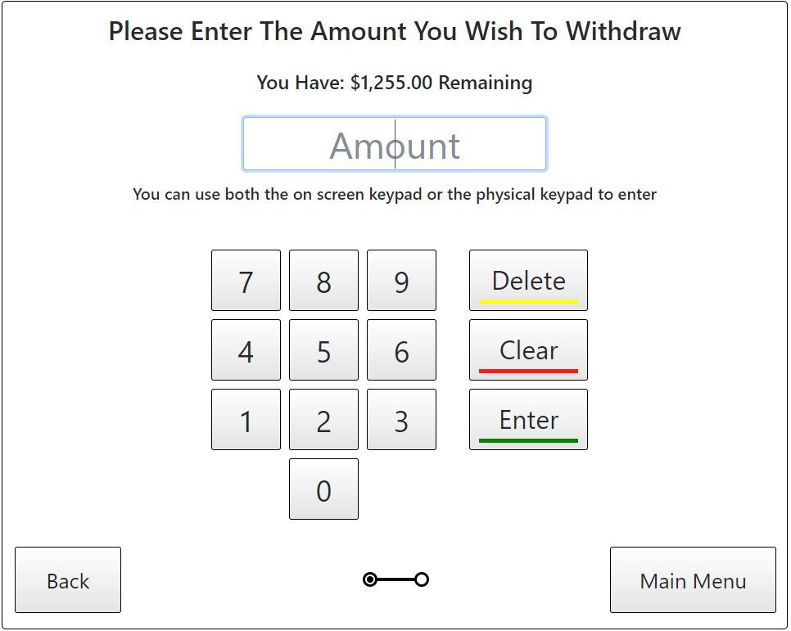

**Figure 10: Withdraw Amount Screen**

When the users type the amount they would like to withdraw, the amount is displayed on the screen giving the users feedback as to the key they pressed. The users’ current balance is also displayed in a label so users know how much money they withdraw at max. The maximum amount of money the users can withdraw is limited by their account type. For demonstrating purpose, this amount is 9,999,999,999. The users cannot enter a number greater than this number. The number pad also constrains the users into withdrawing an integer amount of money. This is to reduce the number of small denomination coins located in the machine. It is assumed that most people will not go to the ATM to withdraw a small amount of money.

The consequences of withdrawing money (whether the withdrawal is successful or not) is described below.

## Success

A withdrawal is defined to be successful if the users enter an amount less than their balance and greater than 0. In such an event, money is dispensed from the ATM. The ATM has a sensor to detect whether the money has been removed. Until the money is removed, the users will be directed to a screen to tell them to take their money. This is so that users do not forget to take their money. The slot that money is dispensed from is also small (and separate from the slot used to deposit money) so that users cannot insert any foreign objects into it. This is so that people do not try to steal money from the ATM, and it prevents users from trying to make a deposit when they press the withdraw money button. Money is deducted from the account balance, and recorded in the transaction history.

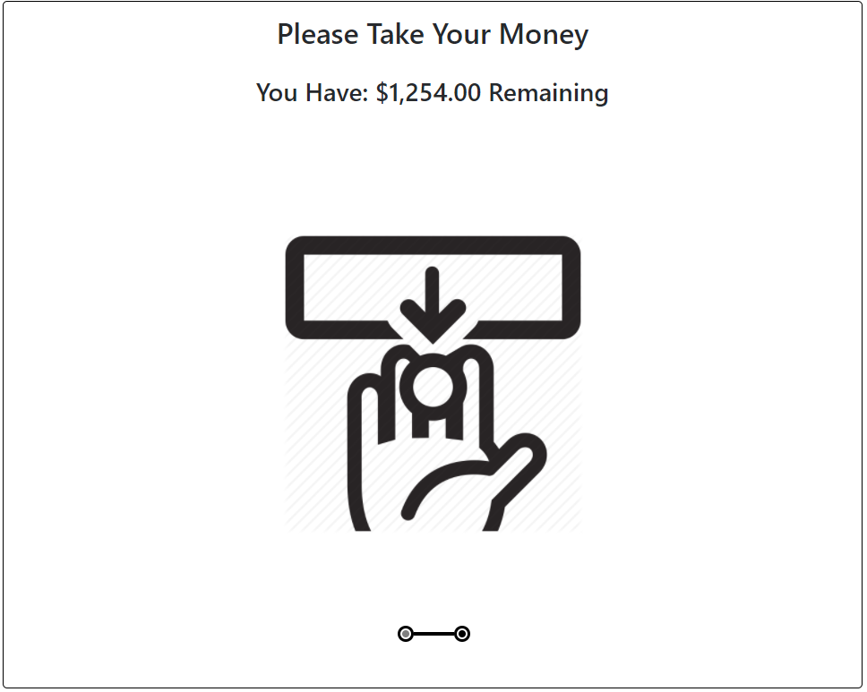

**Figure 11: Success Screen**

Again, text and a picture signal to the users to take their money. Once the users take their money, they are redirected to the main menu where they can choose to preform another transaction or sign out.

## Failure

If the users enter an amount larger than their current account balance, they will be directed to a screen that will tell them that they have insufficient funds. This screen will allow users to go back to enter a new value, or go to the main menu. No money will be deducted from the account balance in this case.

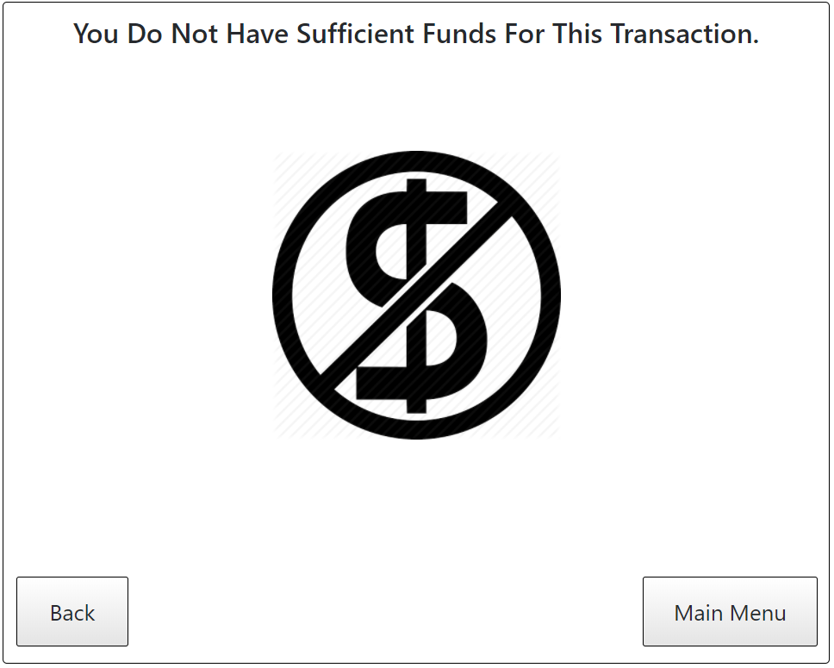

**Figure 12: Insufficient Funds Screen**

# Deposit Money

The deposit button uses an image of a “piggy bank” to denote saving. This provides the conceptual model that when the users deposit money, they are also saving money. It is important to note that this conceptual is constrained by culture: the image might only be usable in Canada, because the notion of saving money in “piggy banks” is widely known. The image of the “piggy bank” may need to be changed if the ATM was used elsewhere.

The users can deposit money or cheque. To deposit, users must first enter an amount they would like to deposit. The interface is similar to the withdrawal interface. When the users types the amount they would like to deposit, the amount is displayed on the screen giving the users feedback as to the key they pressed. The amount the users can deposit is limited by the capacity of the machine. For demonstrating purpose, this amount is 9,999,999,999. The users cannot enter a number greater than the maximum the ATM will take, or, in this case, 9,999,999,999.

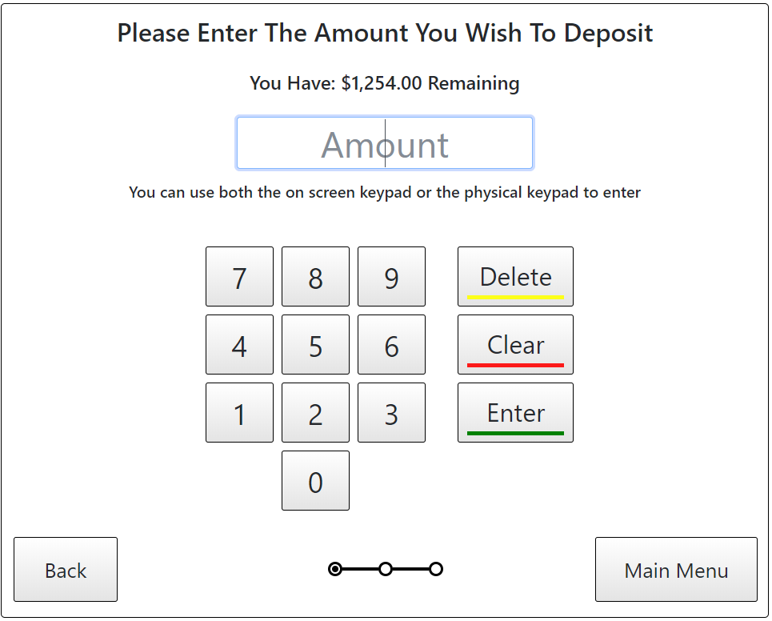

**Figure 13: Deposit Amount Screen**

Unlike the withdraw function, the only constraint placed on the number is that it must be an integer. This is because the number pad does not have a decimal place. This was a reasonable assumption because most people also deposit money in whole dollars instead of fractions of dollars.

When the users press the enter button, they are brought to a screen that asks them to deposit money. On the physical machine, a slot, separate from the withdrawal slot, will open to accept money from the users. Users’ action to insert the money or cheque is simulated with two physical interaction buttons in the application.

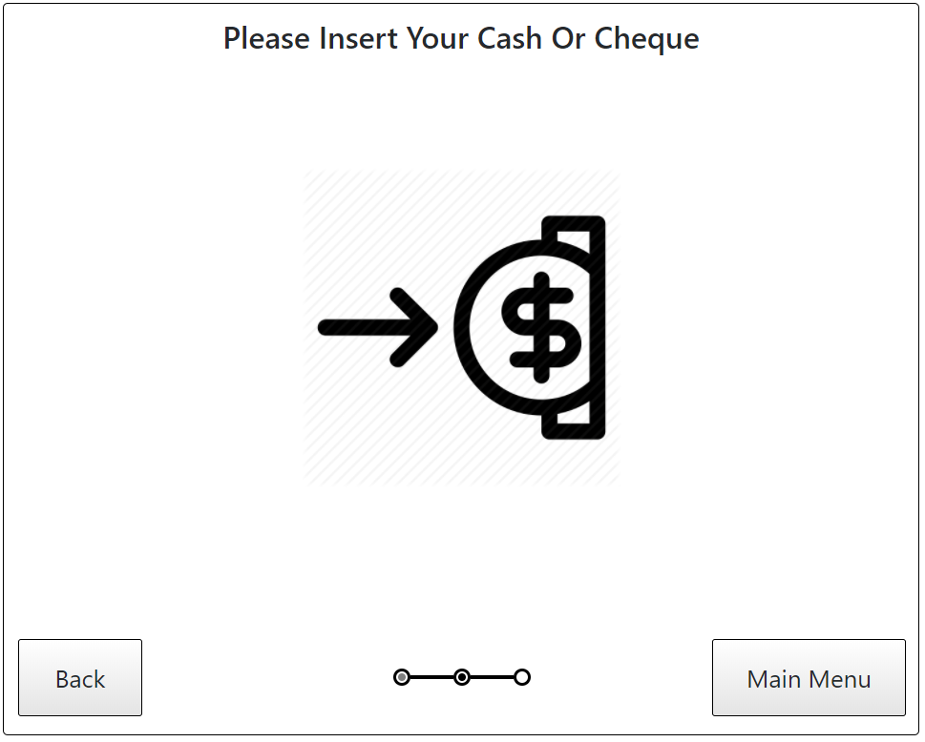

**Figure 14: Insert Money Screen**

As it is up to the users to place money in the machine. If the users place the correct amount of money/cheque in the machine, then they will be directed to a deposit successful screen where they can see their updated balance. Otherwise, users can exit by pressing back to select a new amount to deposit, or main menu.

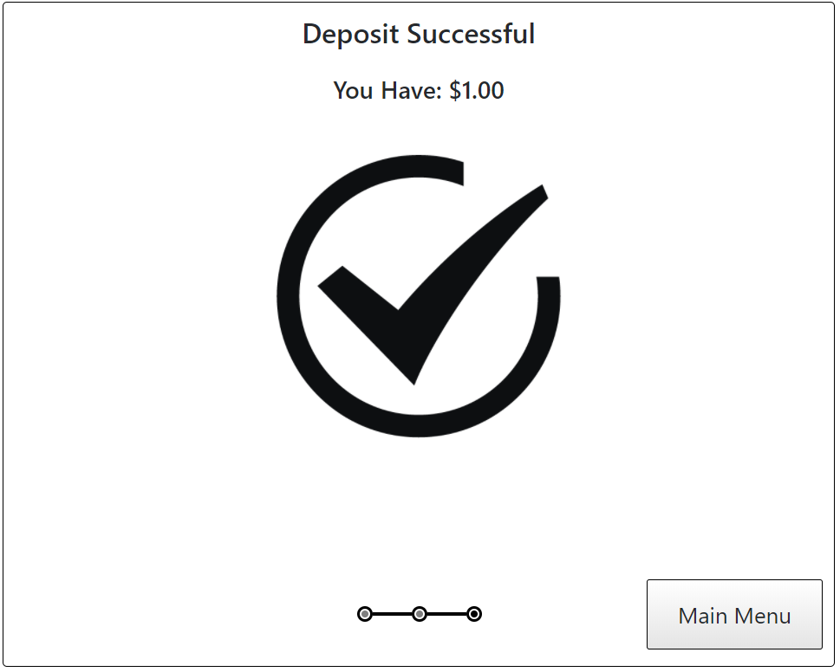

**Figure 15: Deposit Successful Screen**

The users can also insert either incorrect amount of money/cheque or counterfeits. This is simulated through the “Insert incorrect money/cheque” physical interaction button. By doing so, the users will be redirected to deposit failed screen, where they are prompted to insert the correct amount of money/cheque. The users can go back to insert the correct amount of money/cheque or go to the main menu.

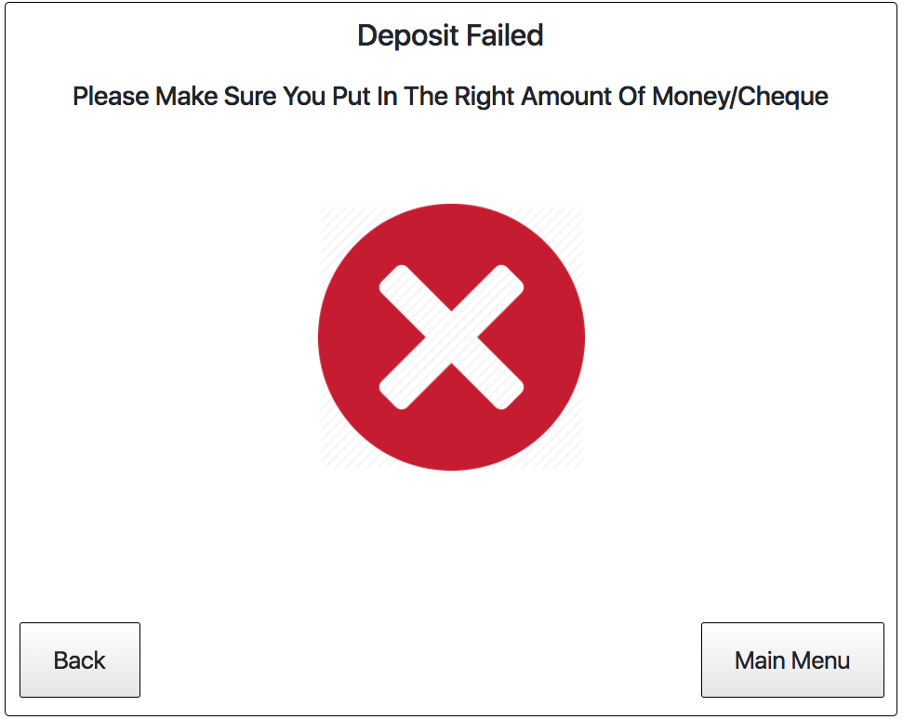

**Figure 16: Deposit Failed Screen**

# Transfer Money

The process of transferring money is similar to withdrawing money, except the balance gets added onto another account. The metaphor of money changing hands is used to show to the users that a transfer is like giving money to someone else.

There are two steps to transferring money: selecting an amount to transfer and selecting an account.

To select an amount to transfer, users must first enter an amount they would like to transfer. The interface is similar to the withdrawal and deposit interface. When the users type the amount they would like to transfer, the amount is displayed on the screen giving the users feedback as to the key they pressed. The maximum amount of money the users can transfer is limited by their account type. For demonstrating purpose, this amount is 9,999,999,999. The users cannot enter a number greater than this number.

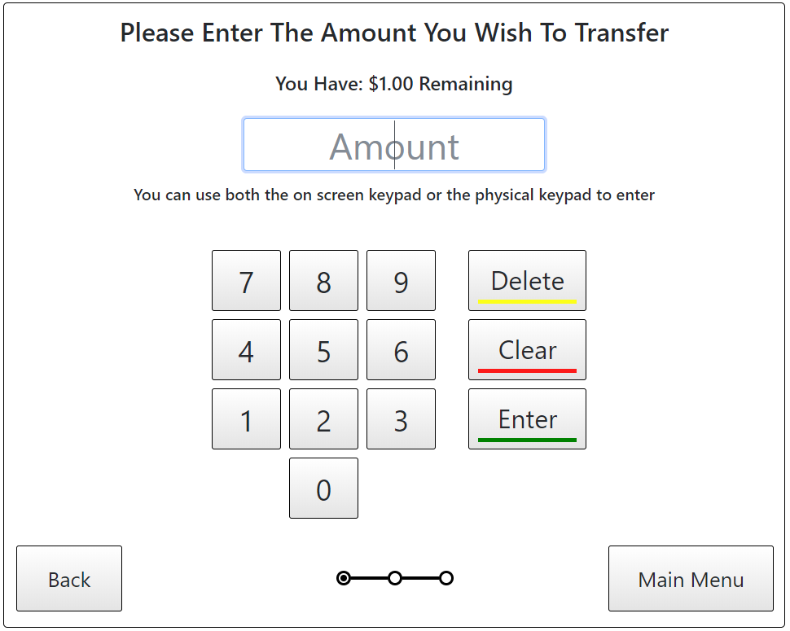

**Figure 17: Transfer Amount Screen**

Users’ account balance is displayed in a label so users know how much money they have. The number pad also constrains the users into transferring an integer amount of money. It is assumed that most people will not go to the ATM to transfer a small amount of money.

The consequences of selecting an amount of money to transfer are described below.

## Success

An amount is defined to be valid if the users enter an amount less than their balance. In this case, the users will be directed to another screen that looks like the bank account number interface, which will ask them for an account number they would like to transfer the money to. Like the bank account number interface, the users is constrained to entering 10 digits. A placeholder, account number, is placed in the input box. It is to distinguish this interface with the previous one, so the users know what number they should enter.

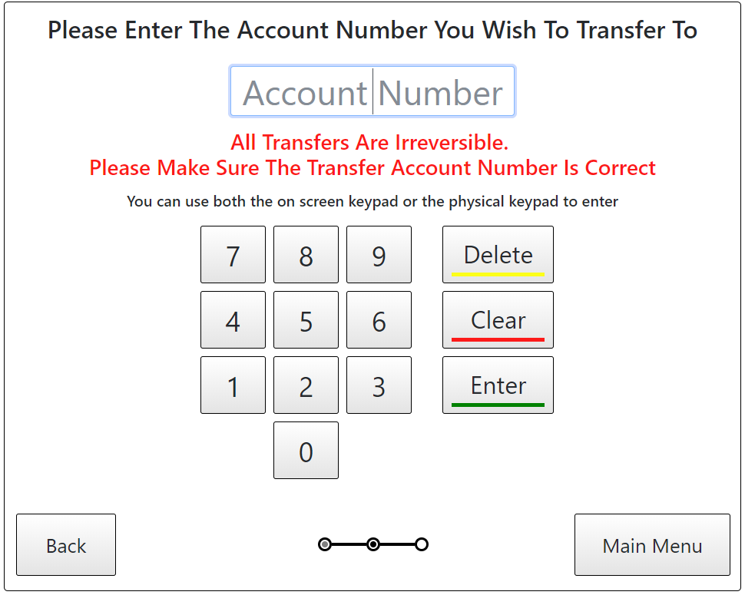

**Figure 18: Account Number Screen**

Transfers are irreversible transactions, so a mechanism must be put in place to ensure that users know the significance and nature of this type of transaction. Several alternatives were considered, including having a confirmation box, or having users type their passcode. However, it was ultimately decided that these additional interfaces will only slow the users down, and users may decide to ignore them all together if they become too cumbersome. Accordingly, a message in red (emphasizing the importance of the message) is placed under the amount text box. It lets the users know that they cannot retrieve the money they transferred to another person, so they should double check to ensure that the account number is correct.

If the users enter a valid account number that is different than the one they are currently using, then the money will be deducted from the users’ account and transferred into the other account. The users will receive a message saying the transfer has been successful. The screen will also show the users’ remaining balance. The screen will give users the option to go back to the main menu.

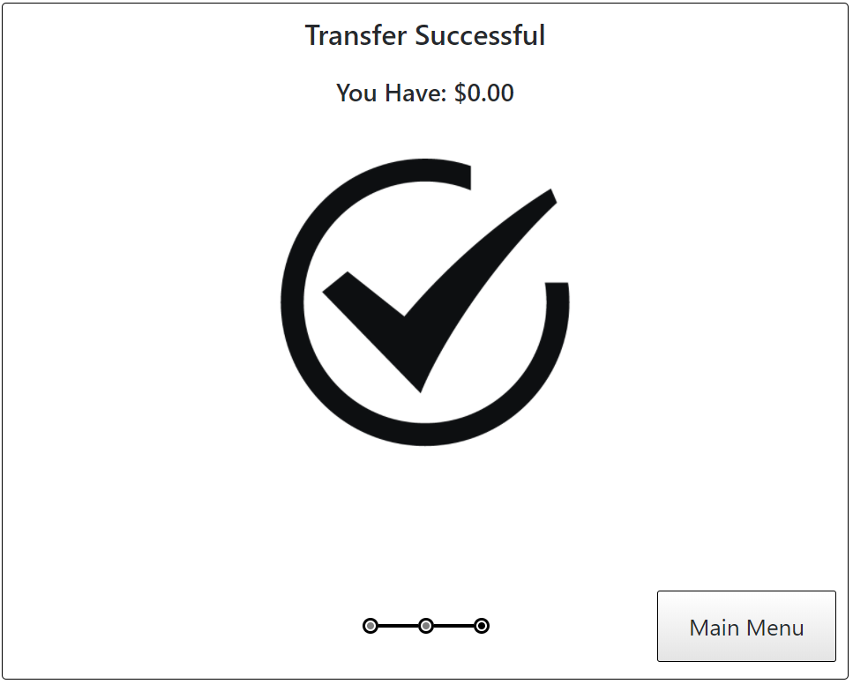

**Figure 19: Transfer Successful Screen**

If the users enter an invalid account number, then they will be directed to an error screen with a red ‘X’ (figure 7). The screen will tell the users that the account number is not valid. The ‘X’ is red because it is important to emphasize to the users the catastrophic effects of their actions. If they transfer money to an incorrect account, then they cannot get their money back.

## Failure

An amount is defined to be invalid if the users enter an amount greater than their balance. Users will be directed to a screen that will tell them that they have insufficient funds (figure 12). This screen will allow users to go back to enter a new value, or to go back to the main menu.

No money will be deducted from the account balance.

# Check Balance

Users can check their account balance by pressing the check balance button. The check balance button has an icon of a receipt being printed. This conceptual model of a receipt being printed is understood by people ages 15 and up because the target population grew up with paper-based banking. This icon and conceptual model may become obsolete in a decade when people grow more accustomed to paperless banking.

Clicking on the check balance button directs users to a screen where they can see their account number and their account balance. Unlike the other screens, this screen does not contain any images. The lack of images draws the users’ attention to their balance and account number. The option to print receipt was discussed; however, since the account balance is already displayed in this screen, as well as most other screens that involves a transaction, it is decided that the option to print receipt will not be implemented. Users will see their account balance on any screen when a transaction is made, thus a paper receipt will not provide much value. It is also eco-friendly to print less paper.

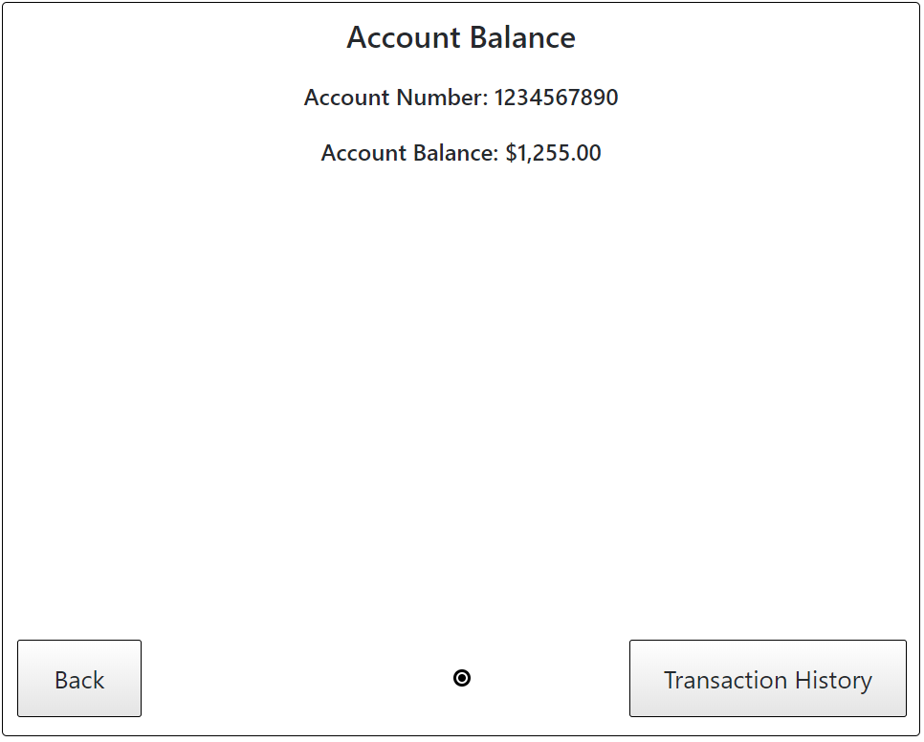

**Figure 20: Account Balance Screen**

If the users want to see all their transactions, they can click on the transaction history button. This will direct them to another screen with their transaction history. The transaction history is shown in reverse chronological order. This is because it is assumed that users are more likely to be interested in recent transactions rather than later ones.

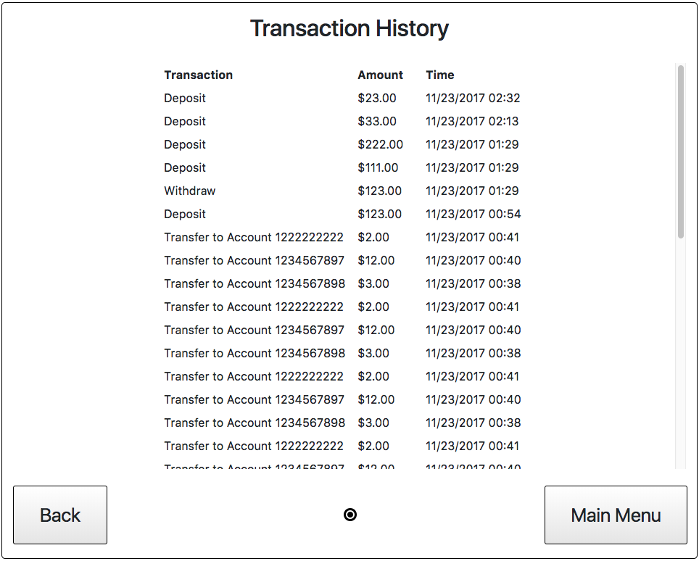

**Figure 21: Transaction History Screen**

Users can see all withdrawals, deposits, and transfers transactions. They will see the transaction type, amount involved in each transaction, as well as the time the transaction occurred. If the users have a long history of transactions, then a scroll bar will appear on the right to let the users know that they can scroll up and down. Scrolling down will reveal older transactions, while scrolling up will reveal more recent transactions.

The scroll bar can also be used to signify the length of the transaction history as well as the current position within the transaction history. A longer transaction history will have a smaller dark grey bar. The higher up the dark grey bar is placed, the more recent is the transaction history shown. This is consistent with the most users’ conceptual model of scroll bars on computers.

# Change Passcode

Since bank accounts have passcodes, a feature was implemented to allow users to change their passcode. The passcode change feature was implemented as some users might share their passcodes with someone else (e.g. a business partner), and situations might arise that require the passcode to be changed to restrict some people from accessing the account.

To change their passcode, users will need to tap on the Change Passcode button. Once they press the button, users are prompted for their existing passcode. This is a layer of security designed to prevent to unauthorized changing of passcodes.

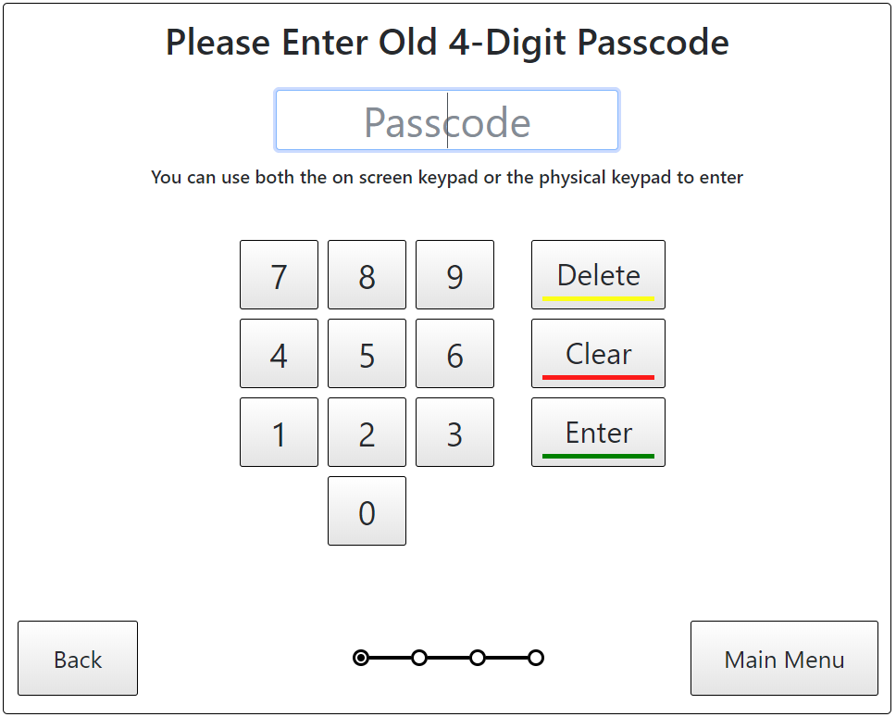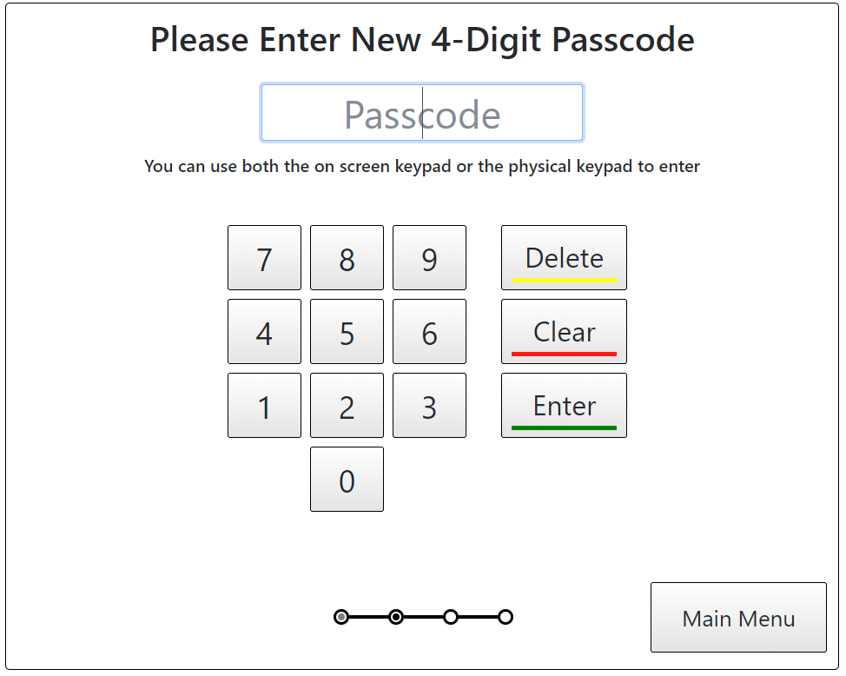

**Figure 22: Enter Old Passcode Screen Figure 23: Enter New Passcode Screen**

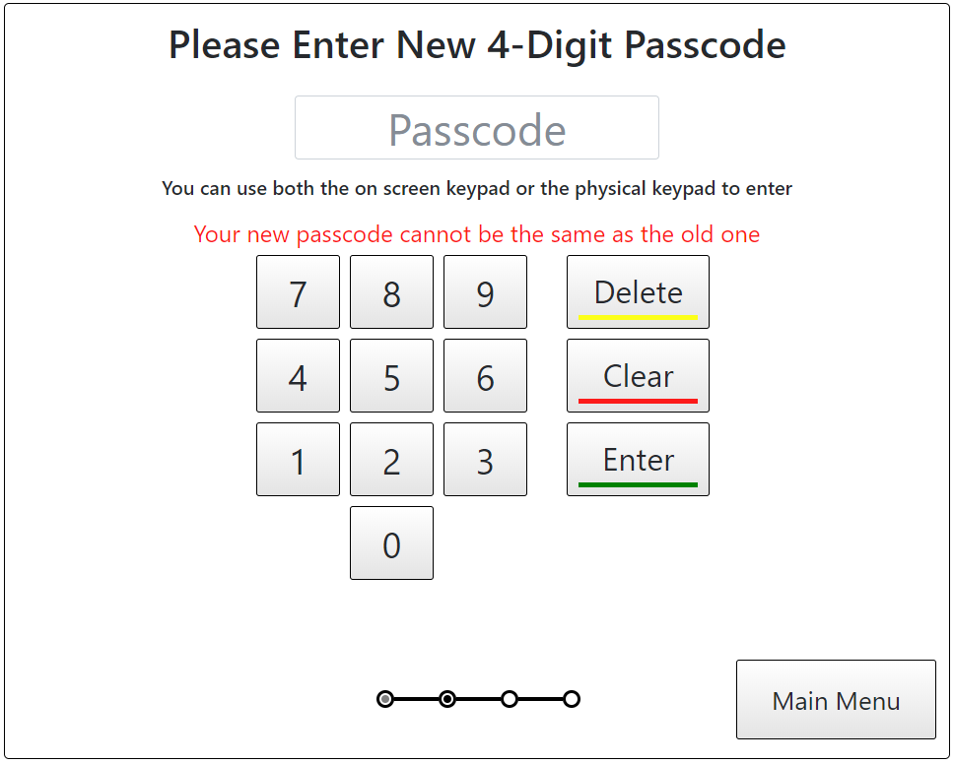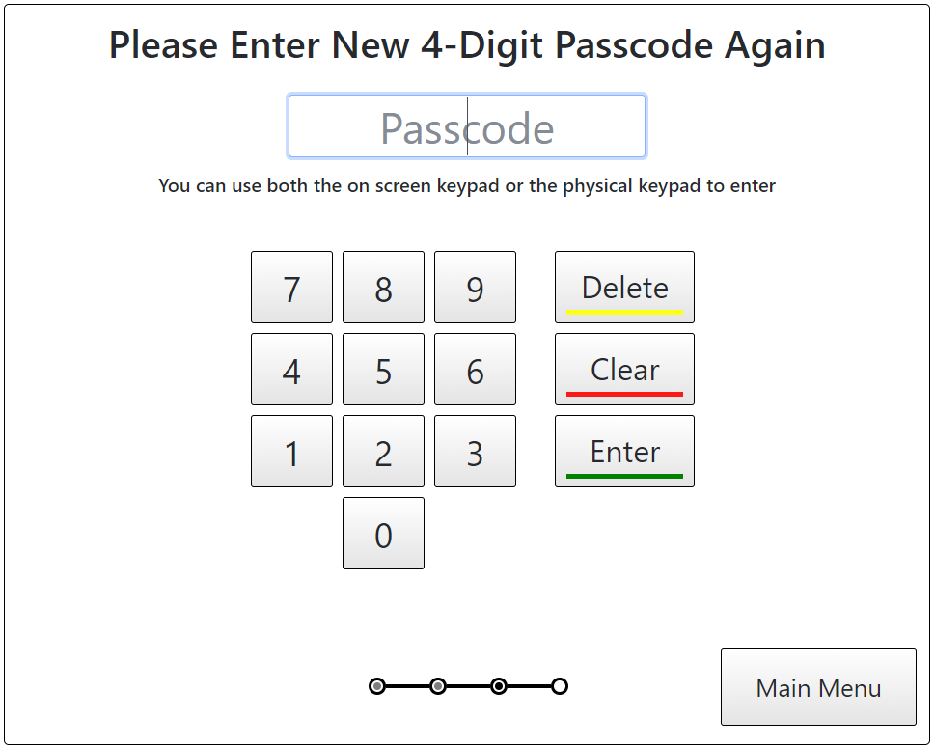

**Figure 24: New Passcode Same As Old Message Figure 25: Passcode Confirmation Screen**

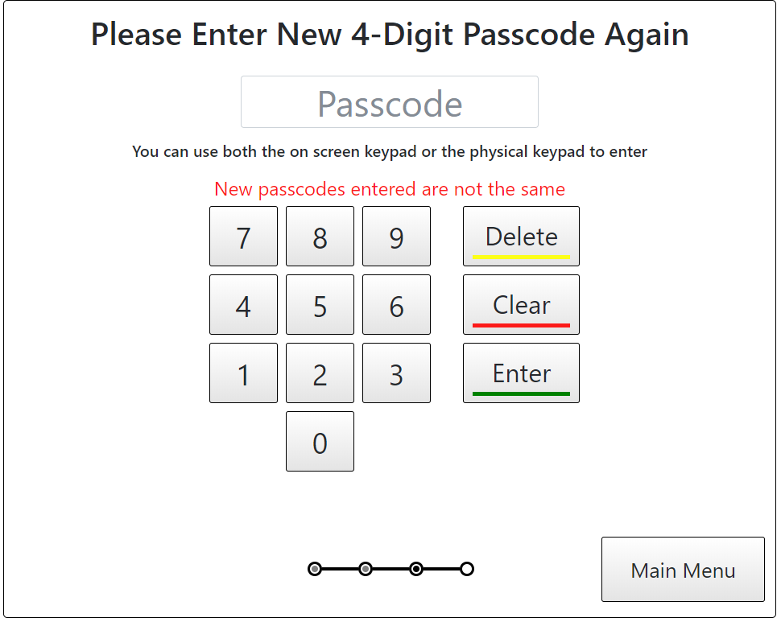 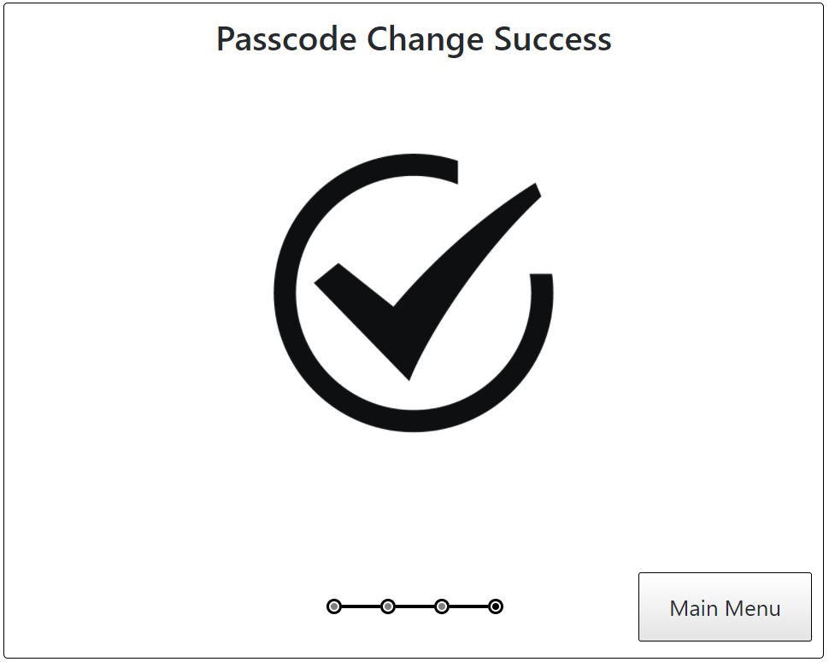

**Figure 26: Passcodes Do Not Match Message Figure 27: Passcode Change Success**

If the users enter the correct passcode, they will be prompted to enter a new passcode. They will be constrained to entering a new passcode that is different from the existing passcode. If the users enter an existing passcode, they will see a red message below the text field telling them to enter a different passcode. Red is used as it is important to emphasize that changing the passcode may have a significant effect on the users’ future experience. The passcode must be 4 digits long, to ensure that the users can remember it in the future.

To ensure that the users did not make any mistake when entering the new passcode, they will be asked to enter the new passcode again. If the new passcodes match, then the passcode will be changed to the new one. Otherwise, the users will be prompted to enter the passcode again.

The users can decide to cancel the operation at any time by pressing the back button or the main menu button.

# Sign Out

Finally, the users can sign out by pressing the sign out button. The sign out button uses the metaphor of exiting a door. This conceptual model helps users realize that after pushing the button, they are supposed to leave the ATM.

This will redirect them to a sign out confirmation which will sign them out of the system.

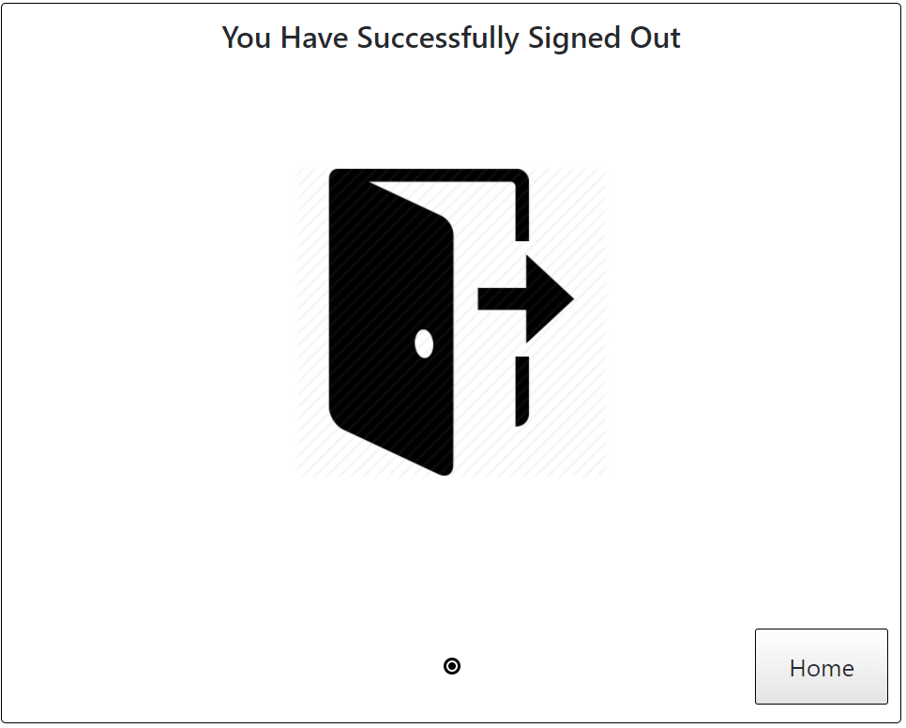

**Figure 28: Sign Out Screen**

Moreover, to account for people who left the ATM before signing out of their account, the ATM will automatically sign a user out after 5 minutes of inactivity.

Pressing the home button once signed out redirects the users to the language selection page (figure 1). If the users do not press the Home button after signing out, the ATM will automatically go back to the language selection page in three seconds.

# Progress Bar

It can be noticed that in most screens, there are circles being connected to each other at the bottom. They intentionally implemented as the progress bar. The progress bar looks like checkpoints in real life, thus it would be easy for users to understand its meaning. It consists of three different circles, grey, black, and white. Grey circle represents the steps that the users have completed; black circle indicates where the users currently are in the process they are; and white circle represent the steps the users have not reached. The progress bar provides feedback to the users. It provides users with state of the program and make the result of their actions obvious. It tells the users total steps for the current process, how many they have completed, and how many there are left. The progress bar changes between steps to give users feedback on their actions. A successful action will move them forward in the progress bar, whereas unsuccessful ones will not. Standalone pages, such as account balance or transaction history, which do not belong to a process, have only one black dot to indicate that.

# The Use of Colour

The ATM interface consists primarily of black and white, except for the occasional spot of red, yellow, and green. The above-mentioned colors are added to the number pad to help users better distinguish between the three functional keys, enter, clear, and delete. The lack of color was intentional as adding additional colour would not enhance the usability of the software; rather, in general, it would only serve a stylistic effect. Instead of adding visual flare, colour was used in this interface to emphasize potentially catastrophic events, such as incorrect passcode being entered, irreversible transfer to another account, or changing an account’s passcode. The lack of colour makes these events appear to be more important to the users, drawing their attention from distractions that may surround them. Moreover, the lack of colour makes it clear that most tasks preformed at an ATM are neutral tasks, with little to no emotion attached.

# Conclusion

This document describes the ATM bank interface submitted by Zichen Jiang and Kelvin Lin for Sfwr Eng 4HC3. The overall functionality and context was provided to establish a mutual understanding about the task at hand: to design a touchscreen based ATM user interface usable to 95% of the working Canadian population while following good design principles. Then, each feature of the application, and design decisions made in the interface was examined. Finally, the use of progress bar and colour in the interface was discussed.

# Appendix 1: Works Cited

1. Statistics Canada. 2006. 2006 Census Topic-based tabulations. (July, 2014). Retrieved November 23, 2017 from http://www12.statcan.gc.ca/census-recensement/2006/dp-pd/tbt/Rp-eng.cfm?TABID=0&LANG=E&A=R&APATH=3&DETAIL=0&DIM=0&FL=A&FREE=0&GC=01&GID=837928&GK=1&GRP=1&O=D&PID=94817&PRID=0&PTYPE=88971,97154&S=0&SHOWALL=0&SUB=702&Temporal=2006&THEME=70&VID=0&VNAMEE=&VNAMEF=&D1=0&D2=0&D3=0&D4=0&D5=0&D6=0